**PART I**

1. A recessive mutation in rough-skinned newts allows for the production of a toxic substance that is harmful when eaten. You capture 200 rough-skinned newts and find that only 18 of them produce the toxin. Calculate the frequencies of the following variables:

|  |  |
| --- | --- |
| p= |  |
| q= |  |
| p2 = |  |
| q2 = |  |
| 2pq = |  |

1. What are the allele frequencies of the dominant and recessive alleles in this population?
2. After the death of a hiker due to poisoning is reported, you discover that flooding during the winter caused a group of newts from the original population to be washed 30 miles downstream. You capture 50 newts in the new pond that has been colonized. Assuming Hardy-Weinberg has been maintained:
3. What are the expected frequencies for each phenotype in this new population of 50 newts?
4. How many individual newts in this new population would you expect of each phenotype based on the frequencies you calculated in “a”?
5. After studying this new population, you observe that 9 of the newts produce the toxin and 41 do not produce the toxin.

|  |  |
| --- | --- |
| p= |  |
| q= |  |
| p2 = |  |
| q2 = |  |
| 2pq = |  |

1. What are the allele frequencies of the dominant and recessive alleles in this population?
2. What are the observed frequencies for each phenotype?
3. **State** the null hypothesis (Ho). Be sure to state both the observed and expected frequencies of alleles or phenotypes in your hypothesis.
4. **Calculate** the chi square value.

|  |  |  |  |  |
| --- | --- | --- | --- | --- |
| **Phenotype** | **Observed (o)** | **Expected (e)** | **(o-e)** | **(o-e)2/e** |
|  |  |  |  |  |
|  |  |  |  |  |
|  | **Total=** |  |  | **Sum (X2)=** |

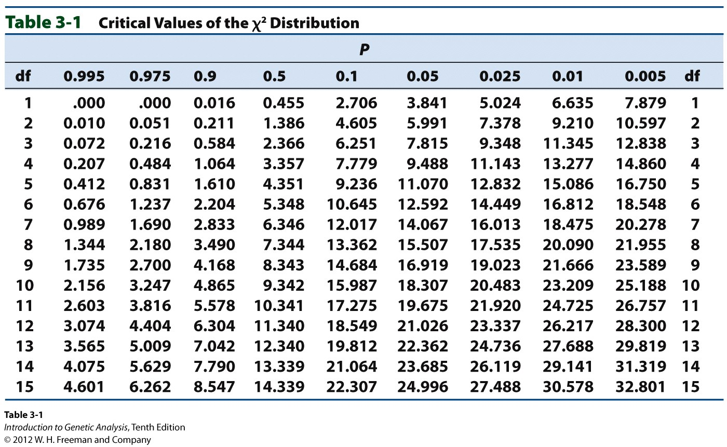

1. **Discuss** the meaning of your chi square value that you calculated.

**PART II**

1. You continue to monitor the new population of newts that was transported downstream. In this new location, garter snakes are plentiful and have been observed actively hunting and consuming both toxic and non-toxic newts. After 6 years have passed another sampling finds that out of 256 newts, 96 produce the toxin.

|  |  |
| --- | --- |
| p= |  |
| q= |  |
| p2 = |  |
| q2 = |  |
| 2pq = |  |

* 1. Assuming Hardy-Weinberg equilibrium has been maintained over the last 6 years, what would the expected frequencies of toxic and non-toxic newts be?
  2. How many newts would you expect to be toxic? How many non-toxic?
  3. What are the allele frequencies of the dominant and recessive alleles in this population?
  4. What are the observed frequencies for each phenotype?

1. **State** the null hypothesis (Ho). Be sure to state both the observed and expected frequencies of alleles or phenotypes in your hypothesis.
2. **Calculate** the chi square value.

|  |  |  |  |  |
| --- | --- | --- | --- | --- |
| **Phenotype** | **Observed (o)** | **Expected (e)** | **(o-e)** | **(o-e)2/e** |
|  |  |  |  |  |
|  |  |  |  |  |
|  | **Total=** |  |  | **Sum (X2)=** |

1. **Discuss** the meaning of your chi square value that you calculated.